RESOLUTION NO.__________

RE: CERTIFICATE OF APPROPRIATENESS UNDER THE
PROVISIONS OF THE ACT OF THE PENNSYLVANIA
LEGISLATURE 1961, JUNE 13, P.L. 282 (53
SECTION 8004) AND BETHLEHEM ORDINANCE NO.
3952 AS AMENDED.

WHEREAS, it is proposed to request approval of the historic plaque location at 27 E. Church St.

NOW, THEREFORE, BE IT RESOLVED by the Council of the City of Bethlehem that a Certificate of Appropriateness is hereby granted for the proposal.

Sponsored by: (s)

(s)

ADOPTED BY COUNCIL THIS DAY OF

(s)
President of Council

ATTEST:

(s)
City Clerk

HISTORICAL & ARCHITECTURAL REVIEW BOARD

Walk – in The applicant is requesting approval of the historic plaque location at 27 E. Church St.
APPLICATION #4: Wa

Mark & Alane Nebbia
27 E. Church St.
Bethlehem, PA 18018

OWNER:

__________________________________________________________________________

The Board upon motion by Connie Glagola and seconded by Derrick Clark adopted the proposal that City Council issue a Certificate of Appropriateness for the following:

- Plaque location will be to the left side of the front door approximately 60” above grade.

- Fasteners will be installed in mortar joints (not the actual brick).

3. The motion was unanimously approved.

__________________________________________________________________________

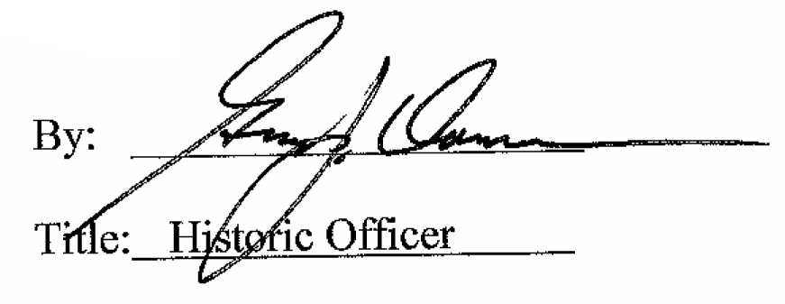

Date of Meeting: May 3, 2017

